Prepare a Cluster with Demo Data:
Local CP installation and OpenTSx flows

Initial data sets

8 time series with different frequencies, sampling rate 100 Hz
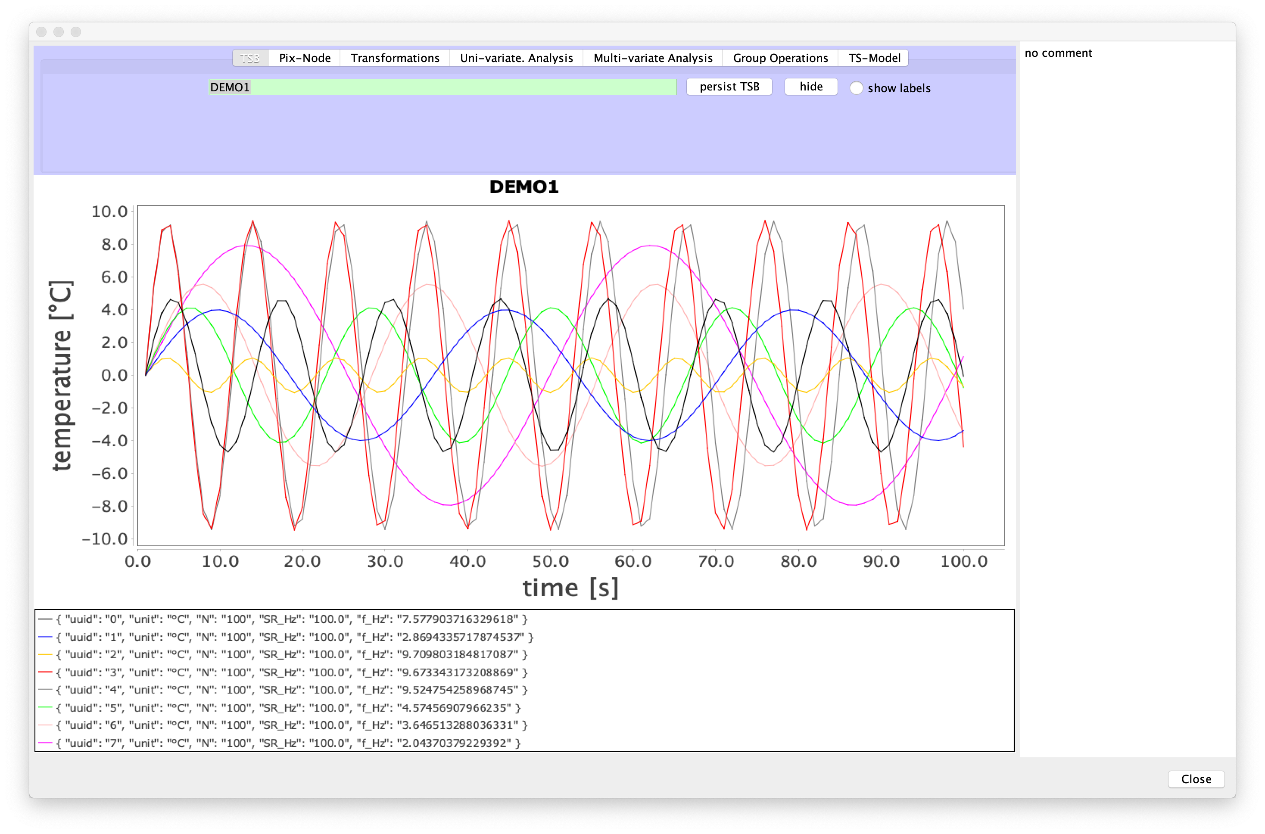
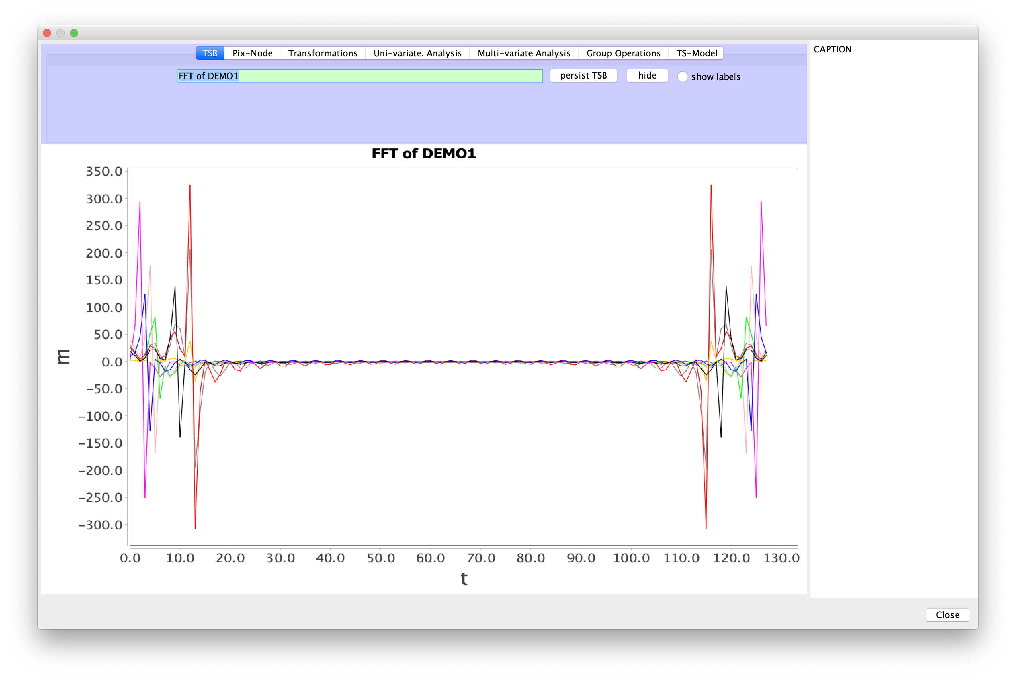
FFT of raw episodes

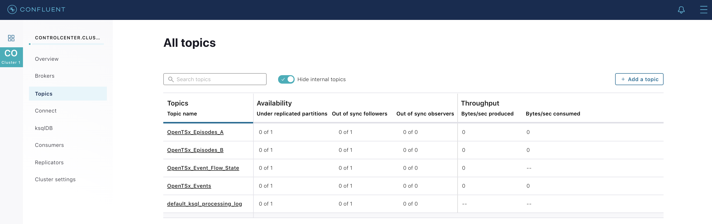
4 topics with raw data

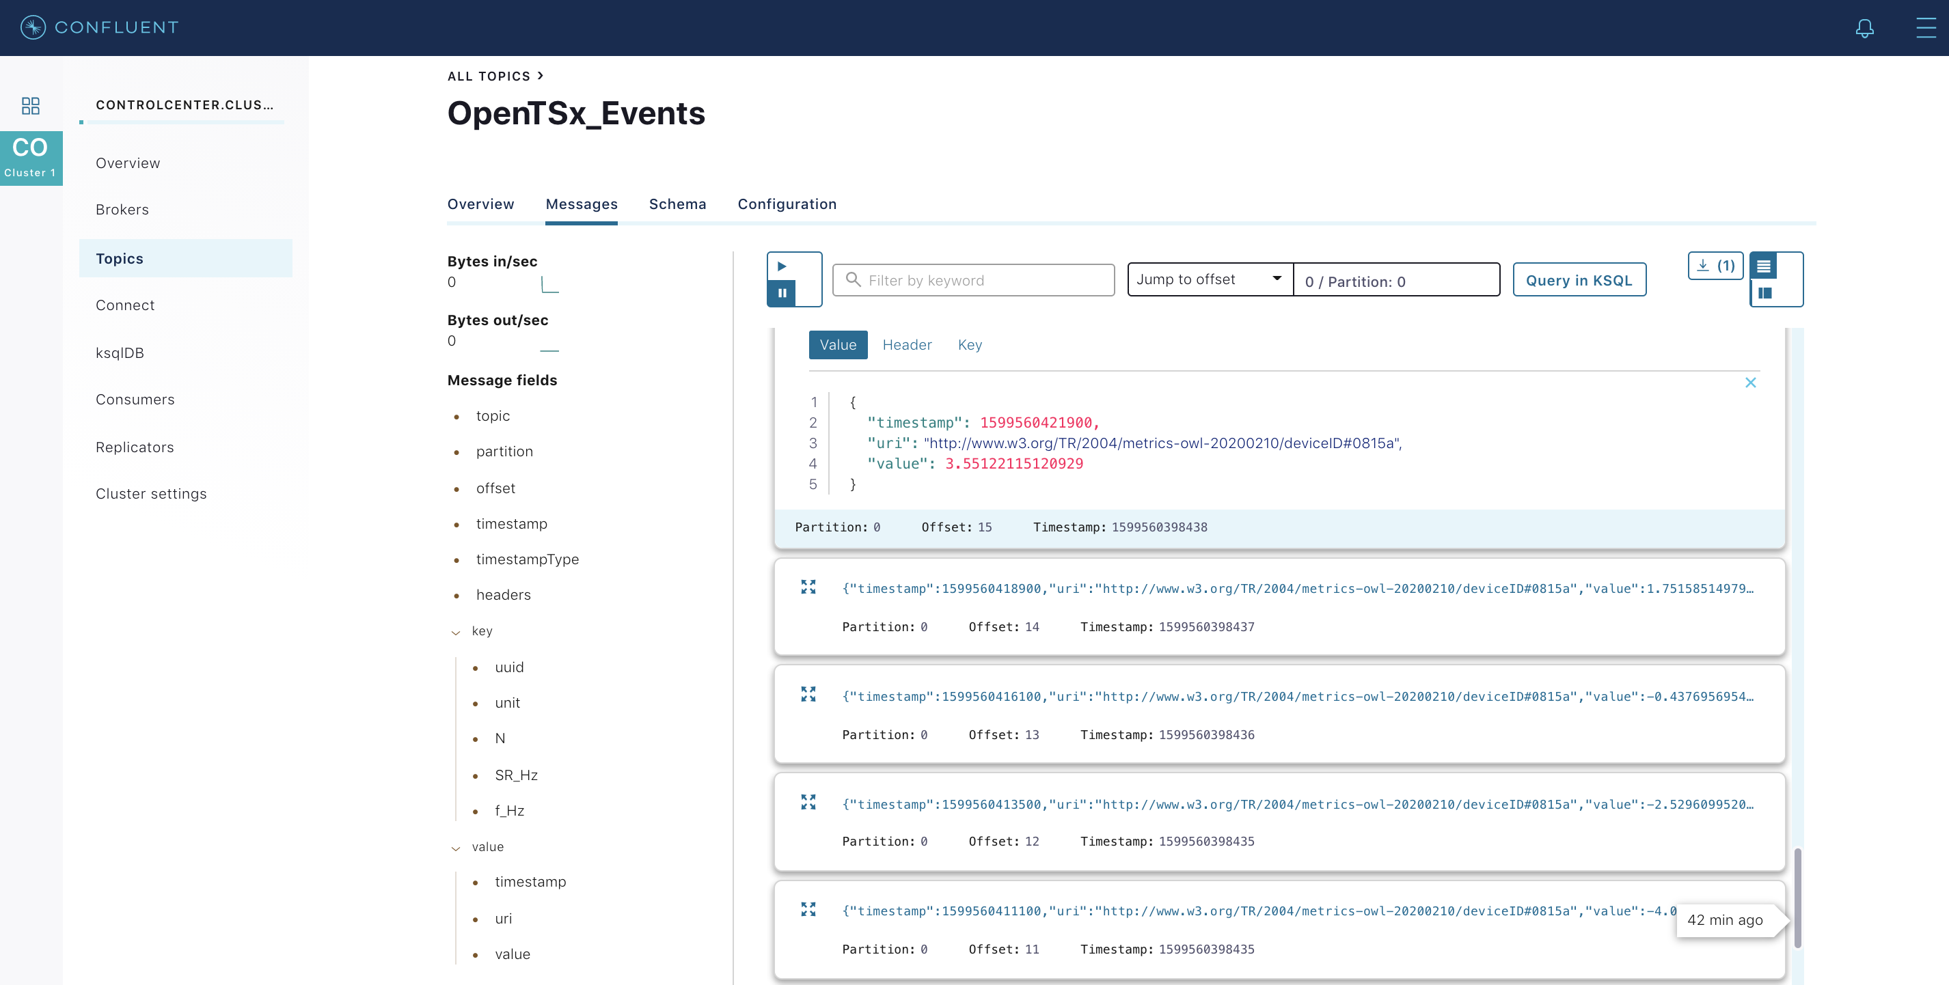
Structured value (Avro)

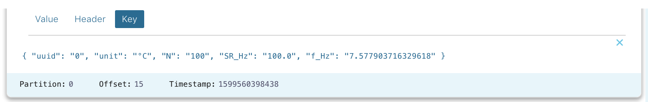
Structured key (JSON string)

Schema for unified data model
Event schema: AVRO
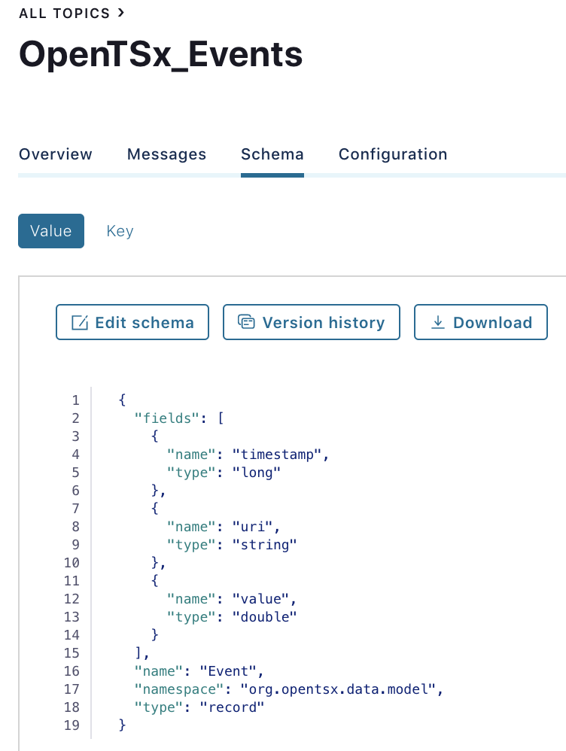

Episode schema: AVRO
http://127.0.0.1:9021/clusters/tEM8XXu1RDKnlIu8clBftA/management/topics/OpenTSx_Episodes_A/schema/value

Prepare Streams over Topics
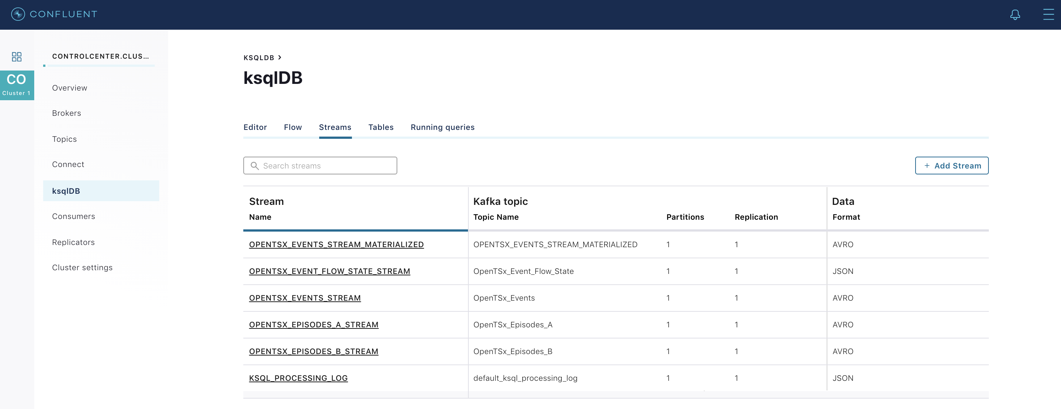
5 streams available

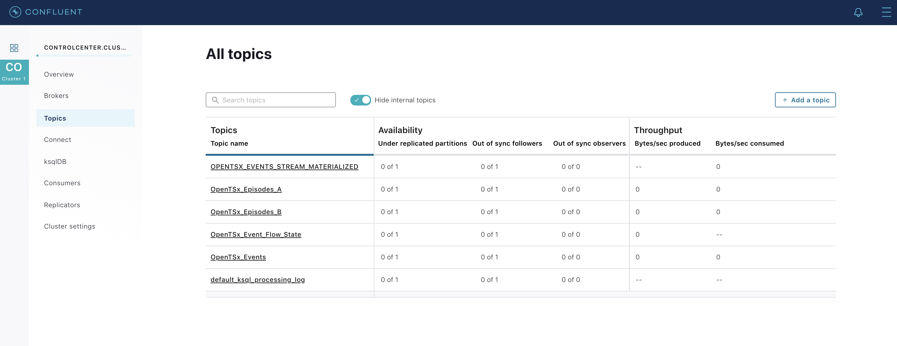
1 new topic for the materialised stream available

Prepare a local KSQLDB instance

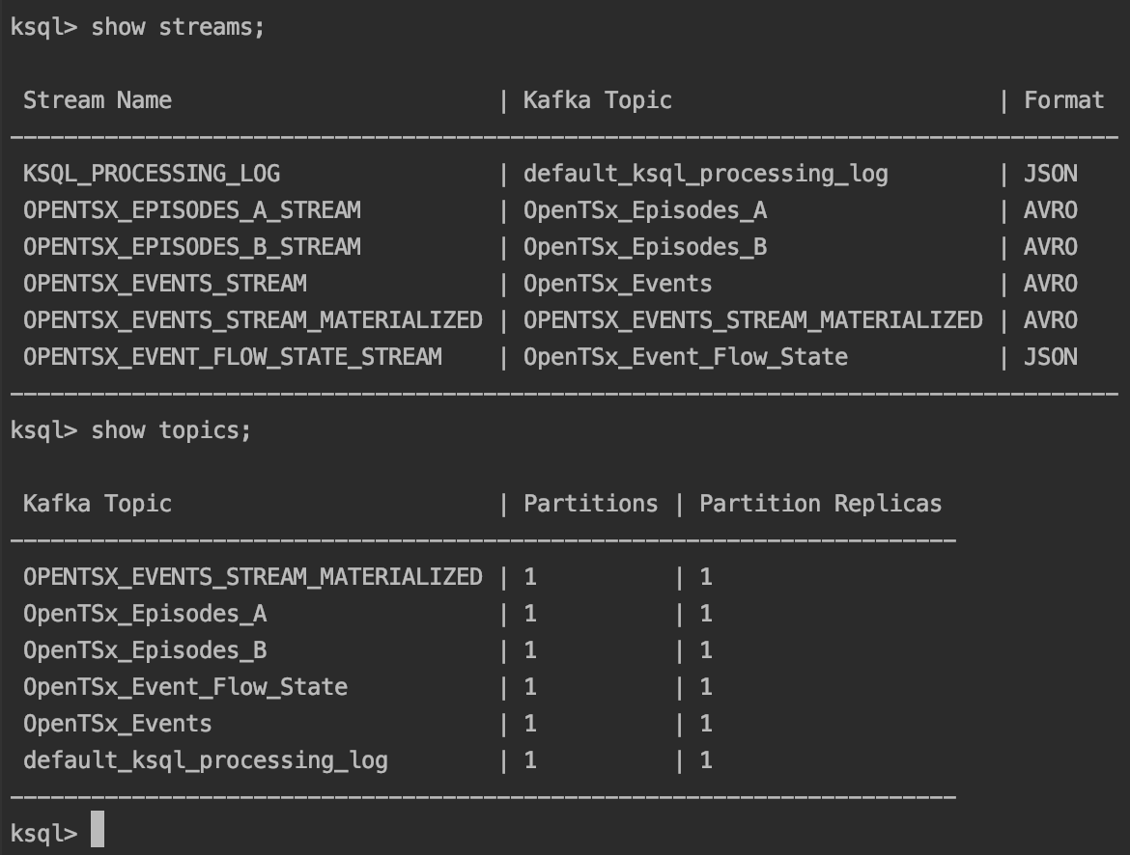
Inspect streams via CLI

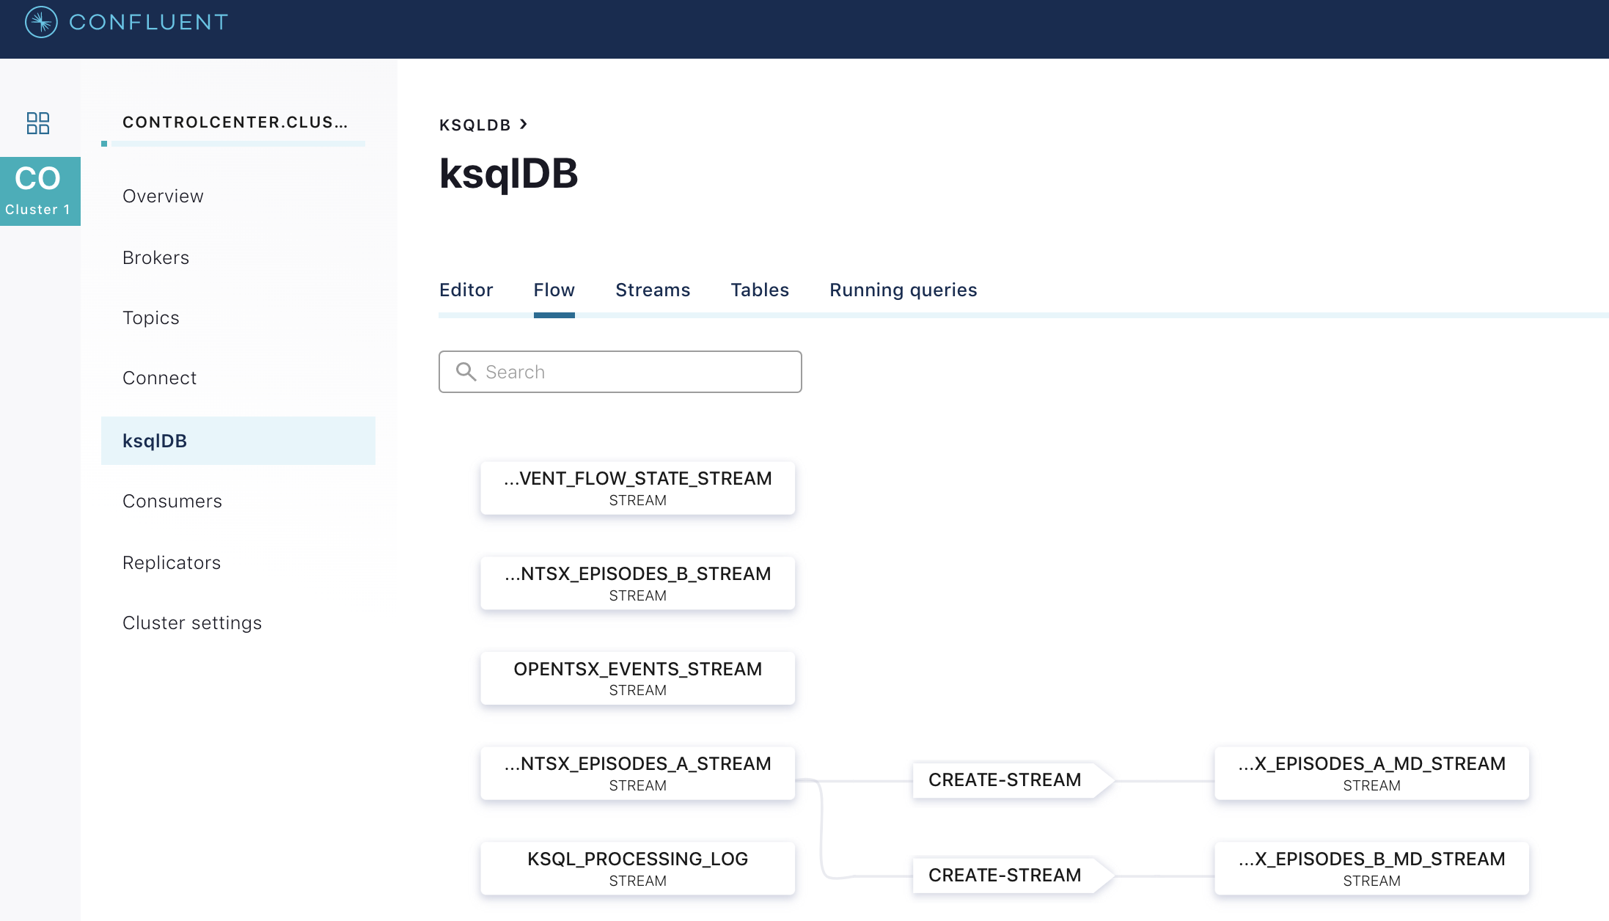
Flows can easily be inspected in the web UI.

Create Kafka Stream Processing applications

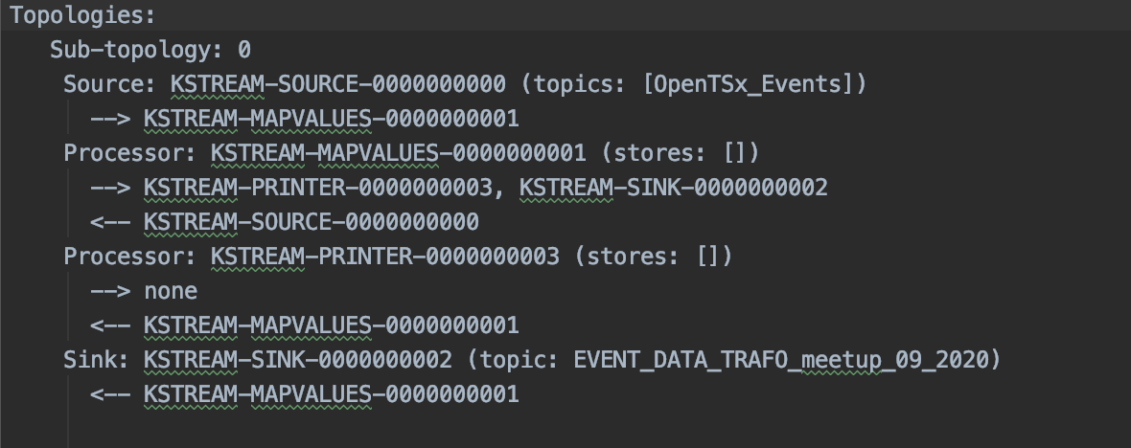
TSAExample1

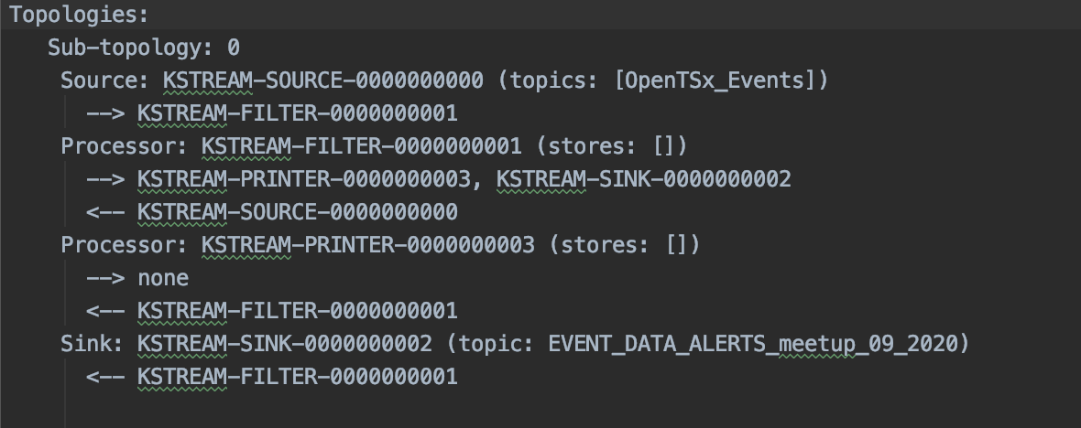
TSAExample2

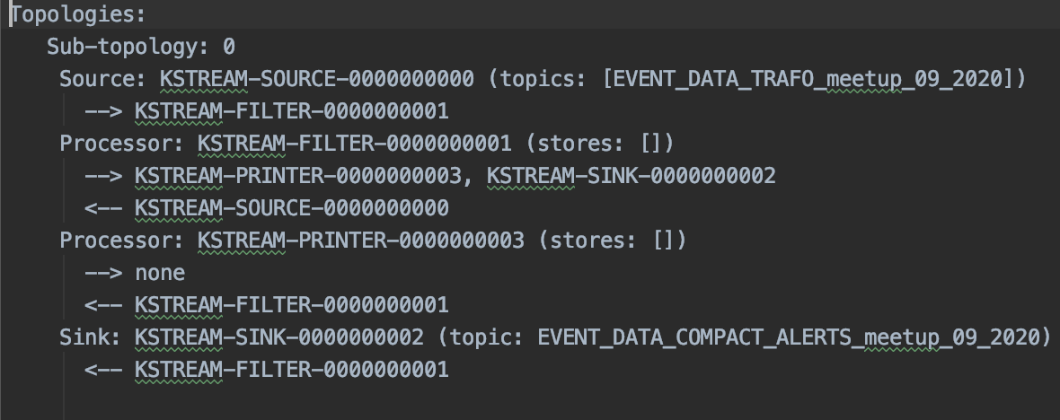
TSAExample3

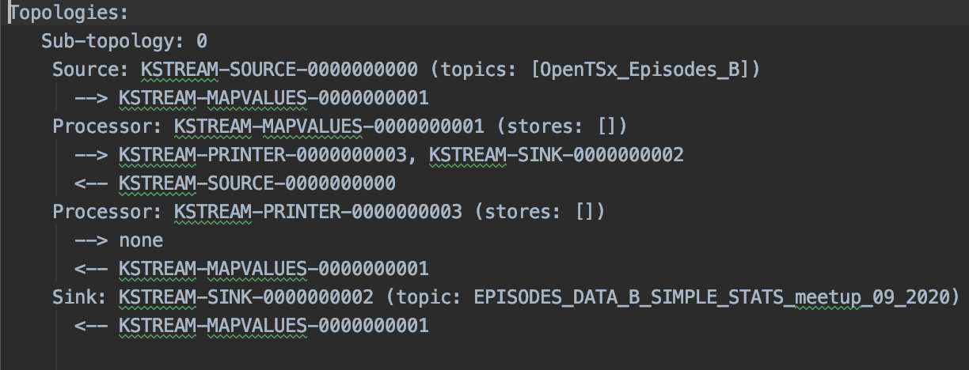
TSAExample10

Data flow visualization

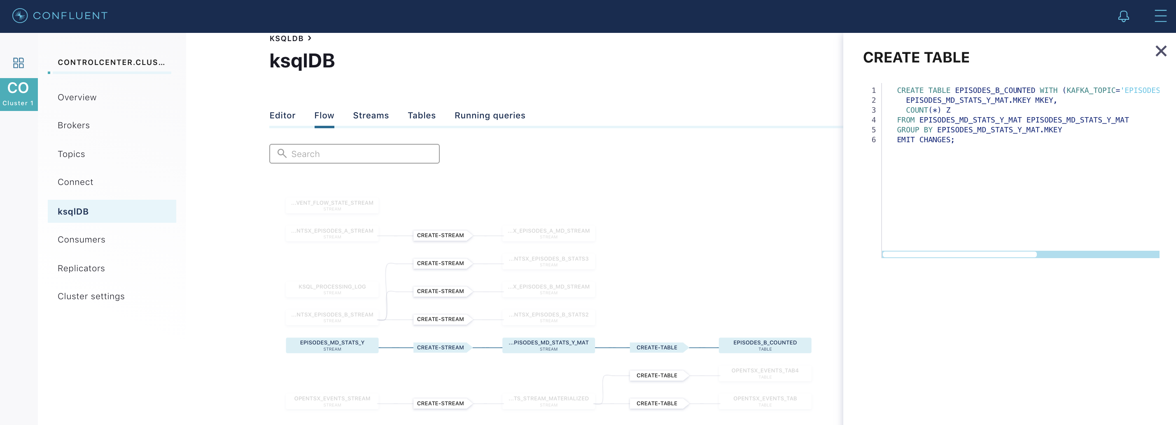
Episodes statistics based on custom properties, calculated in a Kafka streams application.

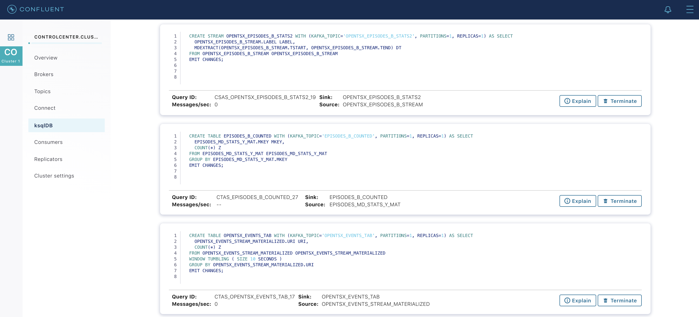
Some running queries … without data

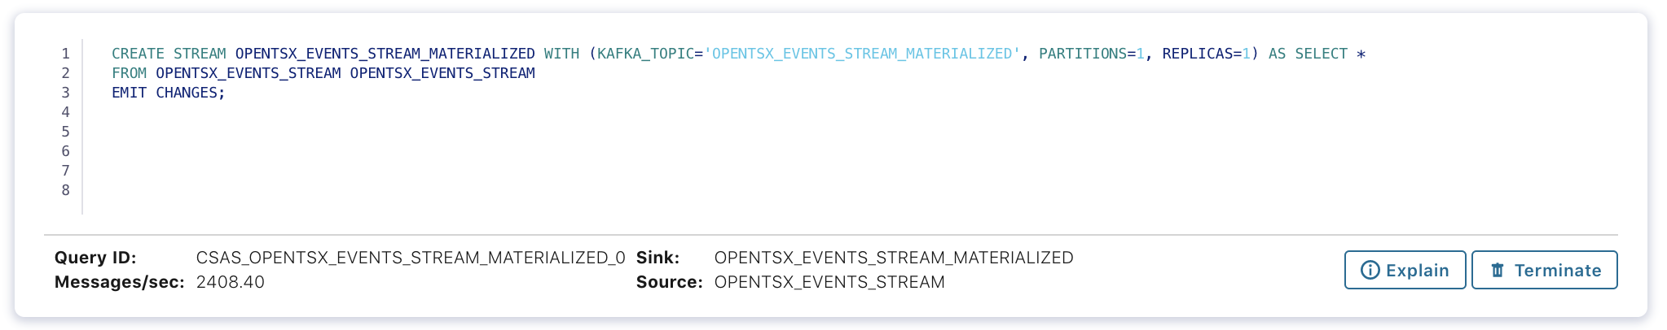
… and now some data flows through the system, 2400 events per second.

Alert processing
Final overview of flows:

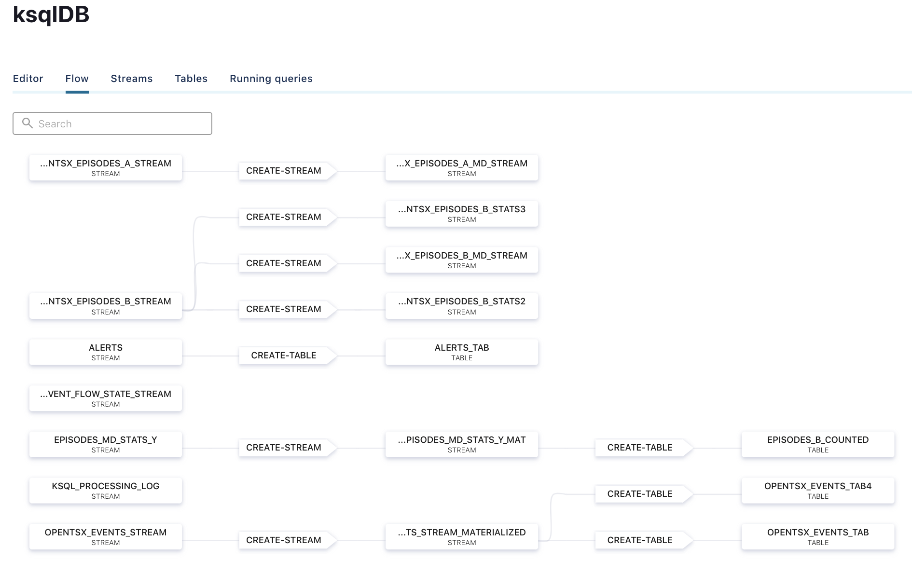

TSAExample2

